## Project Tender

# Project: Chat for Linphone

Kobus Coetzee

Team: Men at Work

Ivan Henning (13008219)

Muller Potgieter ()

Johan van Rooyen (11205131)

Herman Keuris ()

?? ()

Department of Computer Science, University of Pretoria

Date: 2015-05-04

Photo

# The Team

## Ivan Henning

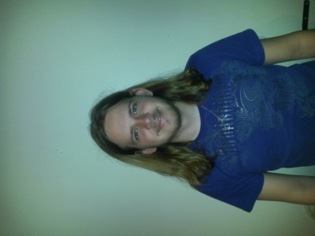

### Interests

* IT programming
* Latest technology
* Gaming
* Sport (cricket, rugby and hockey)

### Technical Skills

Experienced in coding in the following languages/mark-ups/standards:

C, C++, C#, Java, Pascal, HTML, CSS, XML, XSLT, JavaScript, JNode, PHP, AJAX, JQuery and MySQL.

Experience in working in the following fields:

* Operating Systems
* Networks
* Website Development
* Web Systems (server- and client side processing)
* Database management

### Past Experiences

* I am experienced in C and Java and have worked on the open source operating system MINIX.
* Have also worked on a small server and client program sending text messages to each other.

### Non-technical Strengths

* Work well in a team to accomplish goals.
* Quick learner.
* Organised.
* Work well under pressure.
* I'm realistic and debate matters logically.
* Task orientated and objective.
* Thinks outside of the box.

### What makes you want to do the project?

The project about Instant Messaging, which is the buzz word at the moment and is getting bigger every day, looks interesting and would present a challenge especially as it involves the latest technology and apps that people use in their daily lives. My past experience gained would come in very handy in completing this project and the experience that I'll gain would be valuable in the future.

## Joseph Muller Potgieter

### Interests

### Technical Skills

### Past Experiences

### Non-technical Strengths

### What makes you want to do the project?

## Johan van Rooyen



### Interests

* Fishing
* Hunting
* Adrenaline sports
* Computer Games
* Website design
* Electronic components and building small appliances

### Technical Skills

* C++ and C
* Java
* HTML, CSS and Javascript Coding
* PHP Development
* SQL Programming (Database Management)
* Novice Android Development
* Technical Support

### Past Experiences

* Worked as a web developer for 12 months in 2011, writing new and editing existing sites, managing resources on a remote server and working in weekly sprints to finish the project.
* Worked with an international team on a web design project, where meetings took place over Skype and collaborating through an private server made transfer of resources possible.

### Non-technical Strengths

* Good Communication skills
* Collaborate well with a team
* Good business knowledge
* Knowledge of Law in South Africa
* Good time management
* Organizational and Management skills
* Great problem solving abilities
* Go-getter
* Work well under pressure

### What makes you want to do the project?

This project will provide a good experience to me for future reference, since we will be working on an existing technology that is already out there and has been used by the public for quite some time. This will force me to work harder, as there is a lot of expectations to live up to and a lot of eyes on the project.

## Herman Keuris

### Interests

### Technical Skills

### Past Experiences

### Non-technical Strengths

### What makes you want to do the project?

## ??

### Interests

### Technical Skills

### Past Experiences

### Non-technical Strengths

### What makes you want to do the project?

# Project Execution